Quality Standard I: Teachers demonstrate mastery of and pedagogical expertise in the content they teach.

I feel proficient in this standard because I have a lot of practice creating effective lesson plans that foster student learning and experimentation.

Element a: Teacher provides instruction that is aligned with the Colorado Academic Standards, and their districts organized plan of instruction.

Throughout my schooling experience studying how to be an effective art educator, I have learned how to create lesson plans that connect to all four standards. During my education classes previous to student teaching, I struggled with aligning my lesson plans to the standards but I have really improved in creating objectives that I am able to assess. I have practiced using objective statements that help me assess if students are meeting the objectives in alignment to the Colorado standards. I have written at least one statement for each standard which includes how the students will achieve the objective, through what criteria. Below shows an example of objective statements I have written for a high school lesson plan about still-life artwork.
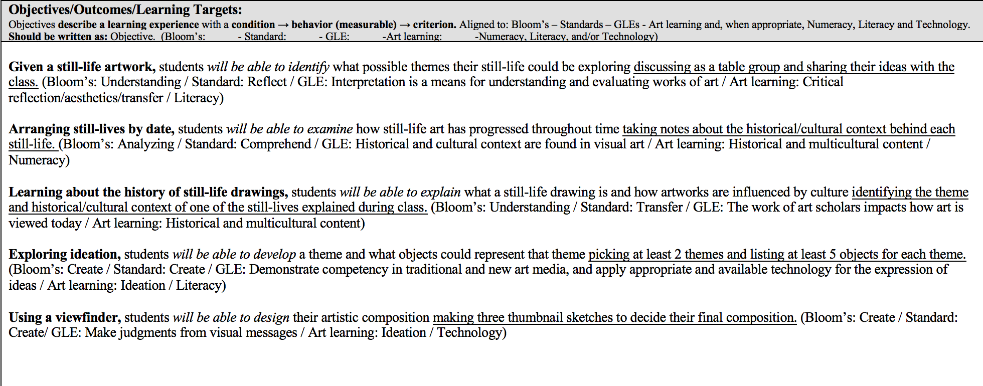
Element b: Teacher develop and implement lessons that connect to a variety of content areas/ disciplines and emphasize literacy and mathematical practices.
When student teaching at Thomas Jefferson High School, I always implemented literacy in my lesson plans. Since one of my mentor teacher’s goal was for students to memorize the definitions of principles and elements of art, I always found a way to get students thinking about the definitions and how they can be applied. For the first lesson, students created self-portraits and they learned about shape and line. They not only wrote the definitions of each word but they also wrote how they used line and shape in their drawings.
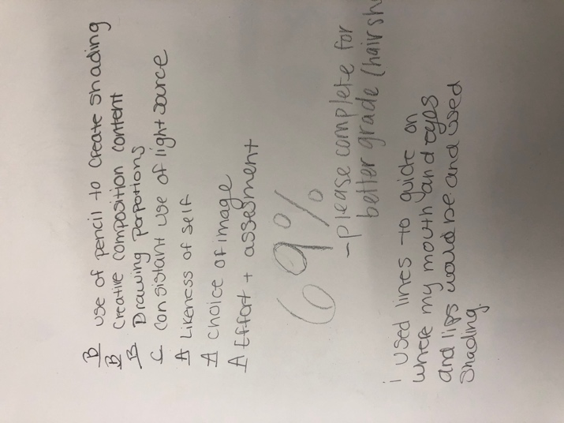
Implementing mathematical practices is a little more challenging for me but I feel like I have improved moving from my first placement at Thomas Jefferson to my second placement at Southmoor. At my second placement, I created more lesson plans that implement different content areas. My imaginary creature sculpture lesson shows one way how I have implemented math. In this lesson, students designed a creature to paper-mache. I explained that the creatures need to be standing and balanced. In their initial sketches, some students drew creatures with big bodies and skinny legs, I asked them if it would stand and if they had any other ideas to make their creature sturdier. This related the lesson to engineering and how designers think about how to make a sturdy structure because they were planning what materials they could use to make a strong creature.
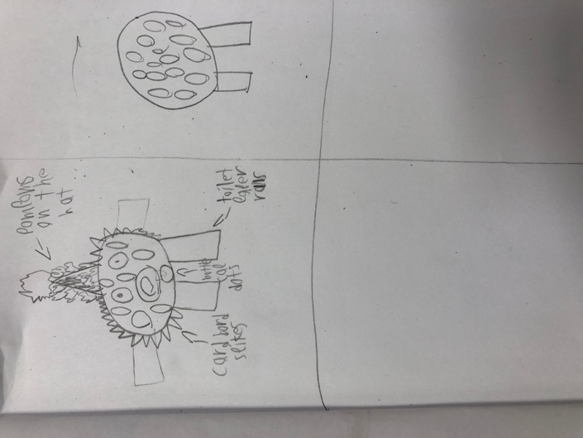

In another lesson that I taught at Southmoor, I implemented science. Students learned about endangered species, how humans affect an animal’s habitat and why a habitat is important to the existence of animals.
Element c: Teachers demonstrate knowledge of content, central concepts, inquiry, appropriate evidence-based instruction practices, and specialized characteristics of the disciplines being taught.
At Southmoor, I taught a 3rd grade lesson about creating a landscape using a process called Batik. With this lesson I came up with central concepts such as: landscape, patterns, foreground and background. Students learned what a landscape is and the difference between foreground and background. Students were also required to create a pattern of some sort in their batik artwork. Students were shown images of batik landscapes made by professional artists and asked the following questions: What do you think these artworks are made out of? What kind of patterns do you see? What is in the foreground? What is in the background?
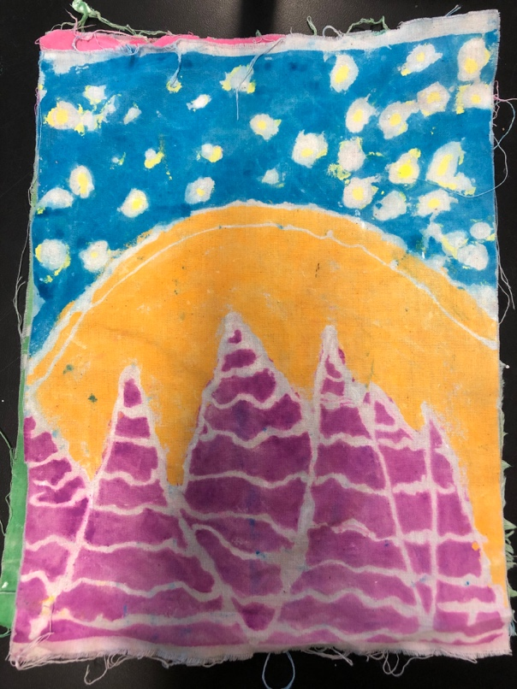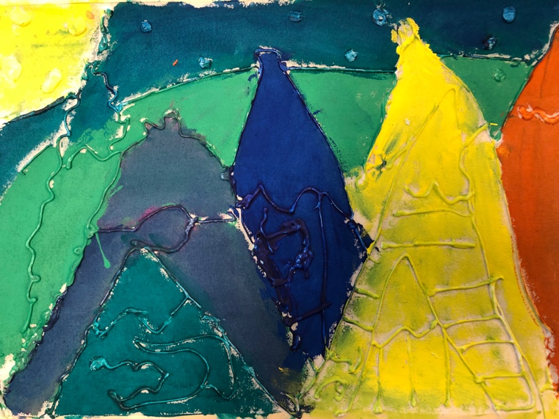

Quality Standard II: Teachers establish a safe, inclusive and respectful learning environment for a diverse population of students.
I mostly feel proficient in this standard, however I still need to improve in some areas.
Element a: Teachers foster a predictable learning environment characterized by acceptable student behavior and efficient use of time in which each student has a positive, nurturing relationship with caring adults and peers.
Starting the year at Thomas Jefferson, I went over expectations with students on the first day. As a class, students came up with class expectations and how everyone should act in an art classroom. I had a piece of poster paper and asked students what expectations we should come up with. Although I liked the idea of students coming up with the expectations, it was difficult to get them to participate. If I were to do this again, I would probably create this during the second week of school after developing relationships during the first week, so that students are more comfortable with sharing out loud with their classmates. I could also give each student sticky notes to put on the posters.
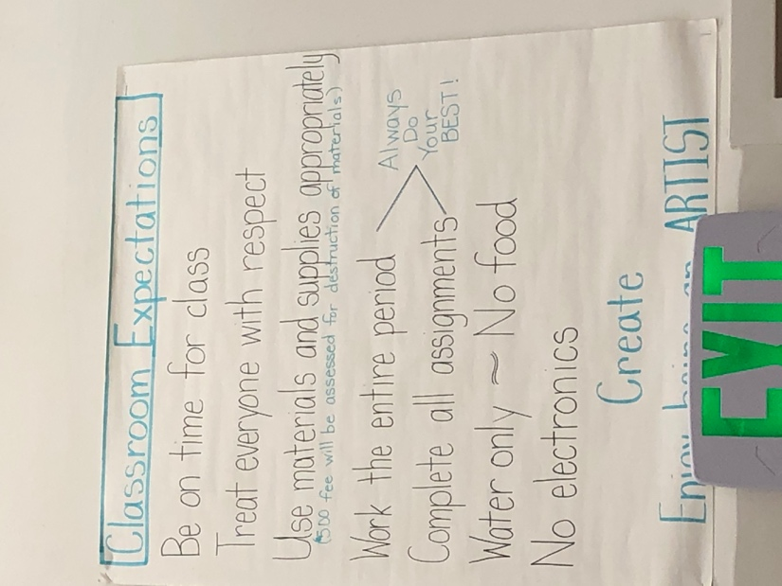
Throughout my student teaching experience, I have worked hard to create positive relationships with students so that they feel welcome and cared for. Beginning at TJ, I noticed that it was difficult to develop relationships with all students because I was so focused on the students who were struggling. I have improved in making sure that I talk to and encourage all students to continue developing relationships. It is also important to keep trying even when a student has a hard outer shell. There was a student in the level 1 drawing class at TJ who would always roll her eyes at me and instead of ignoring her I would stay positive and kept trying to build a relationship. I found a way to relate to her and I saw that she was more willing to work in class.
Element b: Teacher demonstrates an awareness of a commitment to, and a respect for multiple aspects of diversity, while working toward common goals as a community of leaders.
In a white and male dominated society, it is important as a teacher for me to work towards a community where my students feel welcomed and equal. My self-portrait lesson at TJ shows a time when I made sure there was equal representation for the diverse body of students. I was looking for reference photos and how-to-videos for an extra support to help my level 1 students and I saw mostly drawings of white people. In my classes there were a lot of students of color so I made sure to find a diverse array of portraits. I included reference photos of different styles of African American hair because a lot of my students have all kinds of hairstyles.
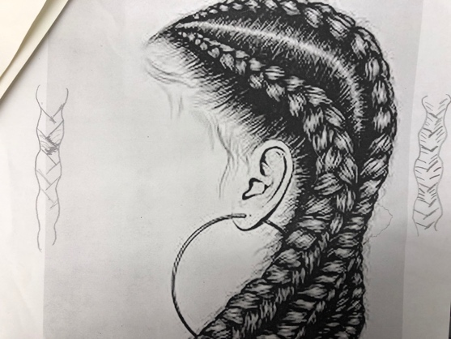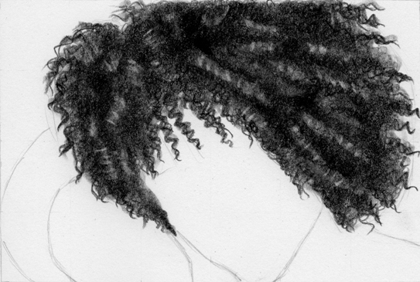

I have learned about the inequalities in the male-dominated art world that favors artists of European descent. As a teacher, I strive to show artists of many cultures and backgrounds. I feel like I am still developing because I need to take more time researching about art from all around the world. I want my students to see that anyone can be an artist which is why it is important for me to show artists of all races and ethnicities, all socio-economic backgrounds and all genders. I have come up with a lesson for 4th grade students where they create a paper-mâché creature and for surface design inspiration, I showed Mexican folk art called Alebrijes.
Element c: Teachers engage students as individuals, including those with diverse needs and interests, across a range of ability levels by adapting their teaching for the benefit of all students.
I can definitely improve in this area. I try to reach all types of learning by verbally explaining, visually showing and writing things down. At Southmoor I have found that a lot of students come up to me and ask what they should do next and this made me realize that not every student can remember by listening to me explain things so I started to write down on the board step by step things to do. I also visually demonstrate what to do to reach the kids who learn by watching.
Element d: Teachers work with families and/or significant adults for the benefit of students.
During my student teaching experience at Thomas Jefferson, I led back-to-school night and participate in parent teacher conferences. During back-to-school night, I talked to parents about what was to be expected and projects that their child would participate in. This helped me build a relationship with parents that would help me be able to reach out to them for extra support. I had one student who would sleep during class and I would try to encourage him but it didn’t help so I reached out to his father who gave me great advice on how to support him. I saw improvement and he would participate more in class with the extra encouragement from his dad. I also communicated with parents during conferences. This was a challenging experience because I am usually non-confrontational but teaching has taught me the importance of reaching out to parents when their child is struggling. I used positive language to explain what their child needs to do to succeed rather than talking negatively.
At Southmoor, I planned a paper-mâché project for 4th graders. For this project, we needed to collect recycled materials to build the sculptures, so I created a flyer to send out to parents. This flyer really helped and a lot of parents sent their kids with an abundance of materials.
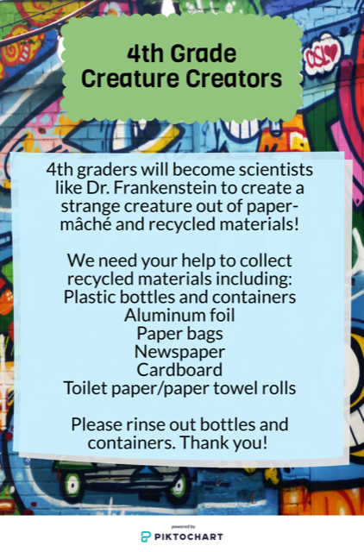
Quality Standard III: Teachers plan and deliver effective instruction and create an environment that facilitates learning for their students.
Element a: Teachers demonstrate knowledge about the ways in which learning takes place, including the levels of intellectual, physical, social and emotional development of their students.
When I student taught at TJ, I attended all of the meetings and one in particular really stood out to me. In this meeting, the school had psychologists come in and speak to the teachers about trauma experienced in teenagers. They talked about behaviors, and the flight or fight response. This made me aware of certain behaviors in teenagers that could be alarming and what to watch for. When a student experiences traumas or have a mental illness, it is hard for them to focus on their learning. This meeting opened my eyes to become aware of the reasonings behind a student’s behavior and how I could support them to help them succeed in school. At TJ, before the first week of school, my mentor teacher received a email from a mother explaining how her child experiences anxiety and how we could support her. One day I saw this student before she came to class, I could tell by the look on her face that she was about to have an emotional breakdown. I made sure to take her to the counselor’s office because I know that she wouldn’t be able to focus on learning and a student’s emotional well-being is the most important aspect for them to learn.
Element b: Teachers use formal and informal methods to assess student learning, provide feedback, and use the results to inform planning and instruction.
During my student teaching, I have constantly assessed student learning to not only help them improve but to also help me improve my own teaching. At TJ I taught a lesson about social justice street art and had students create their own poster about a social justice issue. In this lesson, I had introduced a new technique using gelli printing plates. My students had never used these before so I found a video showing a few technique using the gelli plates. Throughout the artmaking process, I noticed that a lot of students didn’t understand the process of using layers to print or how to use stencils. Due to the lack of understanding that I noticed, I had to do another demonstration for the students who were struggling. At TJ I taught a lesson about drawing objects and I noticed that some students didn’t understand how to create depth on a two-dimensional surface so I took the time to explain how overlapping creates that space as well as placing things higher on the page to make them look further back and lower to make them look closer. Since the level 1 drawing and painting class at TJ was focused on developing skills for students to draw realistically, I was constantly walking around talking to students one on one about how they can improve their drawings. At the beginning of each new lesson, we went over grade expectations. For formal assessments, students got to grade themselves on each criteria and I would take the grade that they had given themselves into consideration but would also grade based on my own thoughts. If I saw that a student was really trying and asking questions to make a successful artwork, I would give them a passing grade on their project and explain how they could improve their artwork. At TJ, my mentor teacher taught me to hold high expectations to encourage students to try their hardest.
Element c: Teachers integrate and utilize appropriate available technology to engage students in authentic learning experience.
At Southmoor, students have chrome books that they can use. My mentor teacher had planned to teach all grades about Claude Monet. To motivate 3rd graders, I had them bring their chrome books to explore the artworks of Monet. I put together an online scavenger hunt so that students would be observant when looking at the works of Monet. I had them compare and contrast two paintings. To engage students even further, I had them go to a 360 video on YouTube of one of Monet’s paintings. As they navigated through the video, they wrote down visual observations and they really enjoyed this activity.
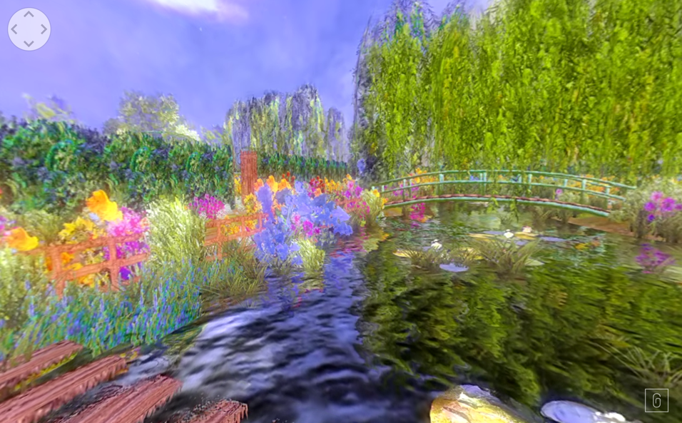
Element d: Teachers establish and communicate high expectations and use processes to support the development of critical thinking and problem-solving skills.
My 4th grade creature creator project really shows how I held high expectations and encouraged students to use their problem-solving skills to create a three-dimensional sculpture. At the beginning of this projects, students had to plan what materials they could use to build their structures. During the building process, if specific materials ran out, students had to problem solve and think about what other material they could use.
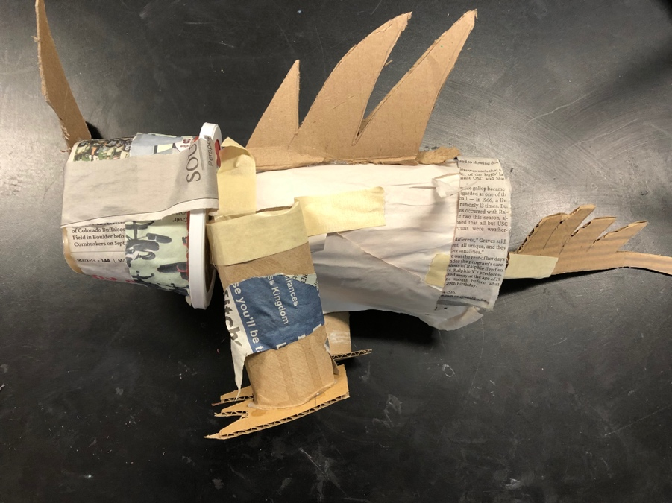
Element e: Teachers provide students with opportunities to work in teams and develop leadership.
To introduce a wire sculpture project at TJ, I planned a teamwork activity. Students had to work as a team to build a certain section of a tree branch that would be a part of the class collaborative sculpture. I encouraged each person in every team to try connecting their piece. Each person got their own piece of wire, but they had to work as table teams to put their pieces together.
I also promoted teamwork in my 4th grade creature creator lesson. If a student finished building their structure or adding the paper-mâché early, I highly encouraged them to go help a classmate.
Element f: Teachers model and promote effective communication.
Every morning before students got to class at TJ, I would always write the learning objectives on the white board. I would start the class period by explaining to students what the day would look like. These daily objectives would include the what, how and why. Below you can find an example of learning objectives that were communicated to students:
- What: Introduction to social justice poster project
- How: PowerPoint and table discussions
- Why: To understand that artists and designers create artwork to communicate an idea
Quality Standard IV: Teachers demonstrate professionalism through ethical conduct, reflection, and leadership.
Element a: Teachers demonstrate high standards for professional conduct.
It is very important to have high standards for professional conduct as a teacher. I strive to be a positive role-model for my students. At TJ, I had access to student grades and would try to encourage students to improve. There was a 9th grade student in one of my classes that was struggling in all of his classes. I encouraged him that he can improve and remained positive. As a teacher it is professional and important to remain positive and to support students rather that discouraging them.
Element b: Teachers link professional growth to their professional goals.
It is my goal to become the best art educator that I can be. Throughout my student teaching experience, I’ve done more research to learn more about art and how to improve as a teacher. I have taken critical feedback and have used it to improve my practice. For example, at TJ my university coach gave me feedback that I needed to implement more technology. I took that feedback and it has improved how I introduce projects and engage students. I also attended the Colorado Art Education Association event, gathered many lesson plan ideas and learned from other art educators for professional growth.
Element c: Teachers are able to respond to a complex, dynamic environment.
I have really improved in this element when teaching at Southmoor. Elementary school kids are always moving and ready for the next step. This taught me to think through my lesson plans and to make sure that everything is prepared for students who finish early. I learned how to multitask by setting up different stations for students who are at different steps in the art-making process. For example, 3rd graders were creating Batik landscapes which required adding a mixture of lotion and toothpaste as a resist, then painting. I set up a painting station and a lotion/toothpaste station so that I didn’t have students coming up to me asking what to do next. Having stations for different steps in the process also helped with classroom management because students were able to figure out what step they were at and what they needed to do.
Element d: Teachers demonstrate leadership in the school, the community, and the teaching profession.
At TJ, demonstrated leadership in the school and community by leading back-to-school night for the art program. My mentor teacher was unable to attend so I stepped up and told him that I would lead this event. During back-to-school night, I introduced myself to parents and showed examples of projects that their child would be creating. I also described skills that they would develop in drawing and painting.

