Laine Stewart
Lesher Climate and Culture
The School Community:
While visiting Lesher Middle School throughout the semester, I have observed an environment that pushes students to not only exceed in their learning but to also grow as a person and discover who they are. I noticed this by attending several events like Shrek the musical, inquiry night, the dance and night at the museum.
My favorite event to attend was inquiry night, I thought this was really beneficial to the students who participated because it allowed them to explore their passions. For inquiry night, students picked an interest that they wanted to learn more about like cooking, drawing, playing an instrument, etc. Students then found mentors who specialized in their interest. This event encouraged parents to get involved as well, parents helped their child find a mentor and provided whatever transportation was needed, some parents were even the mentor for their child. Inquiry night, Shrek the musical and night at the museum also included parents by encouraging them to attend to see what their children have accomplished.
There were also other fun events and activities for students, like the dance. I attended the dance and there were several things to do, there was karaoke, a movie playing in the auditorium, music playing in the gym for dancing and pizza in the cafeteria. I think having a variety of things to do at this event was a great idea and showed the inclusive climate of Lesher. Lesher has a diverse body of students from different backgrounds, ethnicities and even some students from different countries who speak languages other than English. At Lesher, students are encouraged to be themselves, respect others, be creative and open-minded in hopes to contribute to making the world a better place by having empathy for other cultures.

Students and Classroom:
I got the great experience to be a part of Ms. Knips’s technology class. I helped in her 8th grade classes and 6th and 7th grade ELO classes. In the 8th grade classroom, there were few behavioral problems but most of the time students were focused on their projects. There were two specific 8th grade students who were disengaged and weren’t always on their best behaviors. One of them would just put his head down and take a nap instead of engaging in his schoolwork. As a solution, Ms. Knips advised me to take this student for a short walk around the school to help him wake up. While walking with him for a little I discovered that we have similar interests, he likes rap music and the show Dragon Ball Z. Although this particular student was disengaged in the Lesher poster making project, he became more engaged in a project where he could include his interests. For this project, students got to create and design their own game so he created a game with his favorite character from Dragon Ball Z, he even worked on it outside of class. Ms. Knips has created a classroom culture that allows students to express their interests, use their creativity and problem solving skills.
Ms. Knips also created this classroom culture inclusive to all student interests and abilities in her 7th grade ELO class. In this class there were two students who were gifted and talented. While everyone else in the class were working on creating their virtual reality games, these two students created animations on a more complicated program through tutorials that they discovered online. Although they were participating in separate activities, Ms. Knips still included these two students by encouraging them to try their classmates’ games and their classmates were also able to see the animations that they created.
The environment of the classroom is perfect for a technology class. This room has two printers including one that prints out 3D objects. The 3D printer is a cool resource that students can use. Ms. Knips described to me that one of her other classes were creating board games with pieces that were made by the 3D printer. The 3D printer was also utilized to make virtual reality goggles for games created by the students. This classroom has nice technology and enough computers for every student in the class. There is also a smart board that is used for instructions and for students to sign in by dragging their names to the bottom half of the screen. Below is a layout of the classroom:
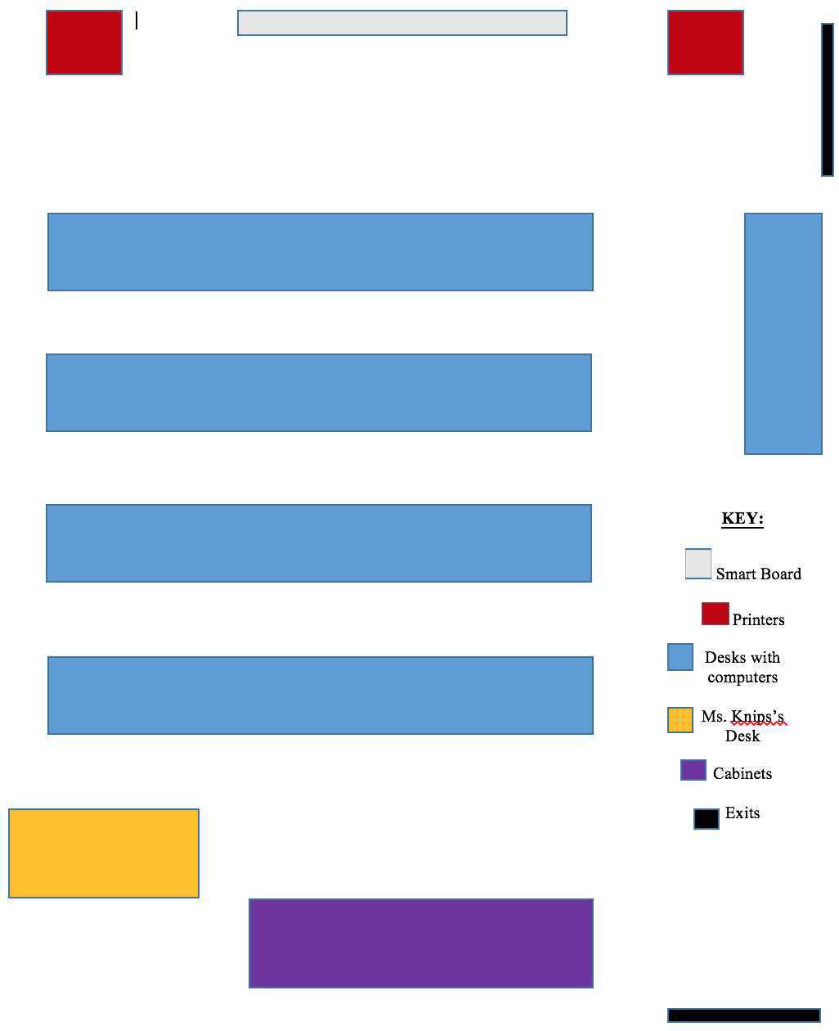
Topic and Rationale:
Throughout the semester, I saw Ms. Knips using strategies that I would also use as a future teacher in my classroom. When students were off task, Ms. Knips would give them a “redirect.” When giving redirects, Ms. Knips gave students a chance to correct their behavior. After Ms. Knips gave one redirect to a student, she rarely had to give another. I only saw one time where Ms. Knips met two boys out in the hall who were running around the classroom, but after she talked to them, they changed their behavior. During announcements students would talk to each other instead of listening. Ms. Knips gave out candy to students who were silent and taking notes during announcements. This helped a lot, kids love candy and it encouraged them to pay attention. I saw Ms. Knips rewarding good behavior in other ways as well and I like this strategy instead of punishing bad behavior. She mentioned to the students that if they were well behaved, then they would get to use the “vive,” which is a very expensive virtual reality device. This worked well, students improved their behavior because there was incentive.
In addition to classroom management strategies, Ms. Knips used good strategies to assess students. To assess after projects, Ms. Knips gave students self-assessments that they filled out. For the project where students created their own tiny house on google sketch-up, they provided evidence to show that they used all of the required tools. I think self-assessments are beneficial because students are more likely to be honest and they can reflect on what they have created. Another strategy that Ms. Knips used when assessing students was directing a gallery walk where all students walked around to see everyone’s work. She asked her students about what creations they liked and why. Ms. Knips also facilitated an online gallery walk in Minecraft that also allowed students to vote for their favorite exterior, interior and yard. This got students excited about their work and willing to put in more effort to create something that would impress their classmates. These strategies used by Ms. Knips show that she has created an inclusive classroom environment that is fair and fun.

